**VPC 02**

1. Create one VPC, with 1 public subnet and 1 private subnet.

* Login to aws console,
* Navigate to vpc
* Create avpc , and give CIDE range
* 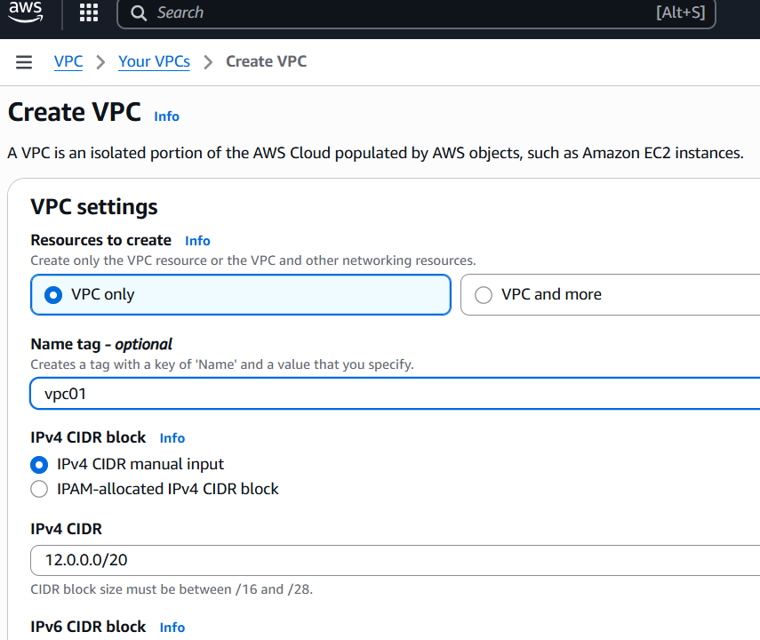
* Navigate to subents and configure created vpc to it but creating 1 public sunet and private subnet
* Public 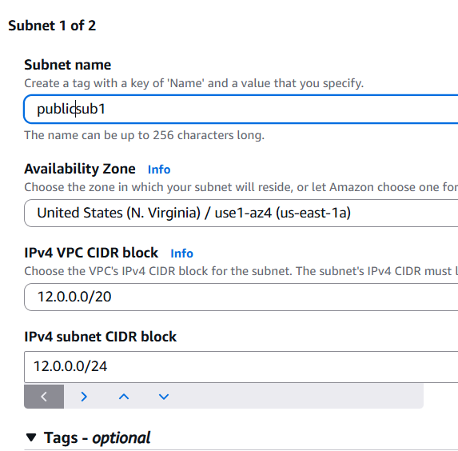
* Private 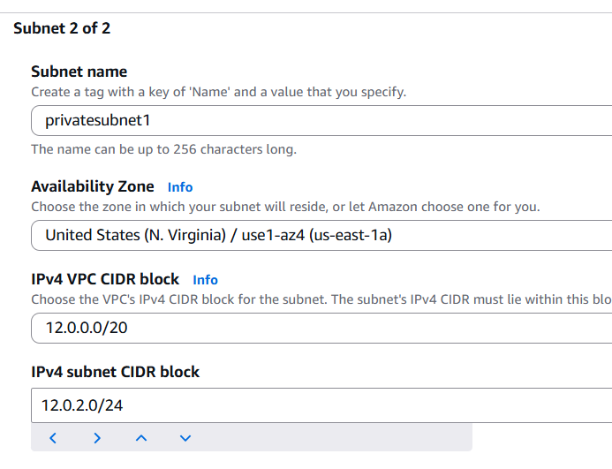
* Now select the subnet and c lick actions give select auto assign ip addres for fot both public and private subnets
* 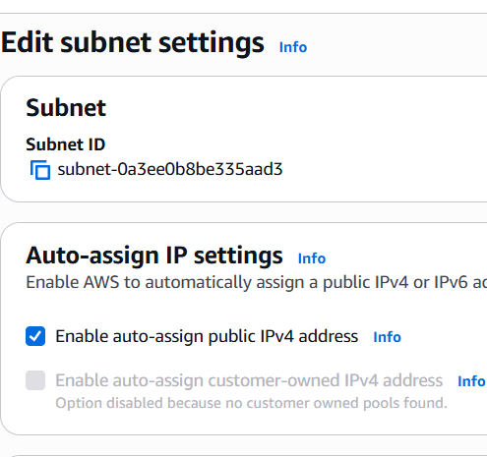
* Now navigate to internet gateway and create one
* 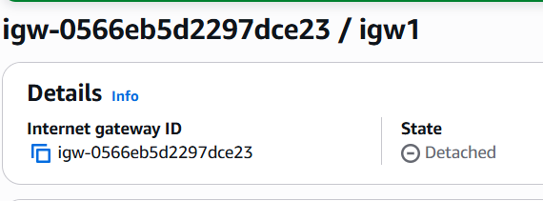
* And the internet gateway to vpc01
* Now navigate to route tables , create 1 public route table and 1 private route table
* Add public association in public routetables
* Add internnate gate to tables through editing the routes
* 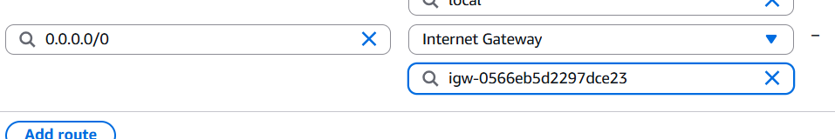
* Now launch an instance in ec2
* Using created vpc
* Now connect
* 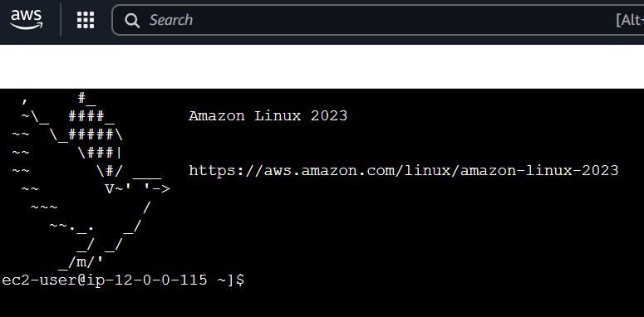

1. Enable VPC peering for cross-region.

* Created a new vpc in north virgina region
* Navigate to vpc dashboard
* Select peering connections

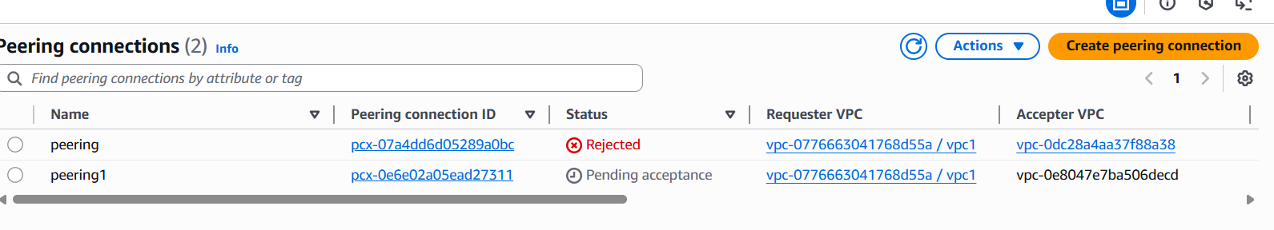

* Now create a peerin g connections
* Give vpc requester and vpc accepter from 2 differnet locations
* 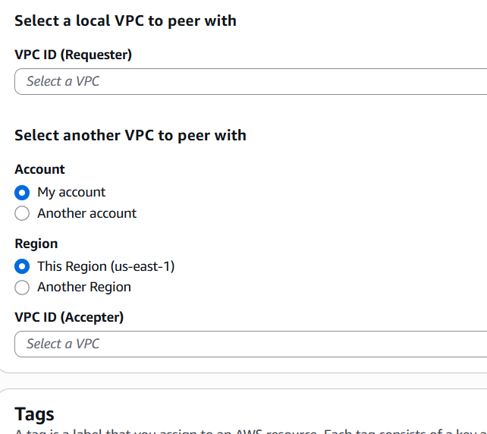
* Now navigate to my vpcs
* Select peering connections
* 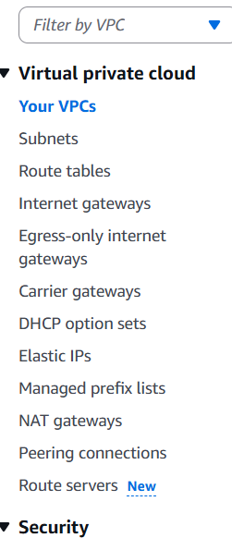
* Select the peering connections and accept it
* 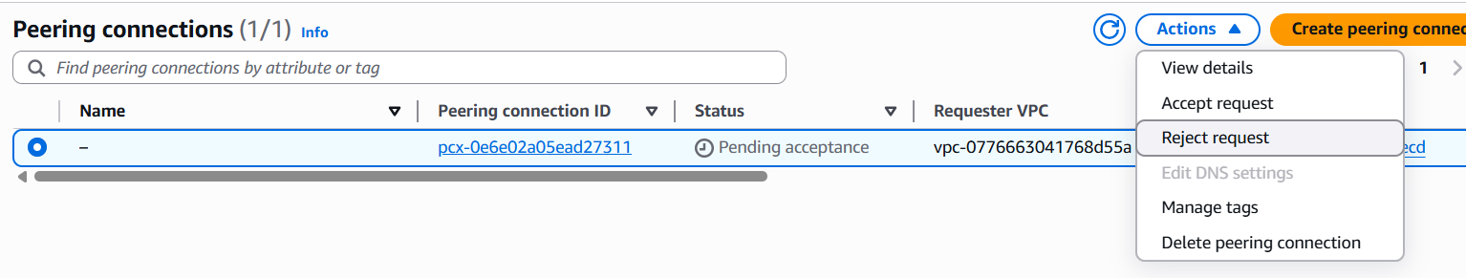
* 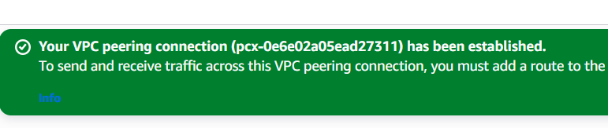

1. . Set up a VPC Transit Gateway.

* Create 2 vpcs
* 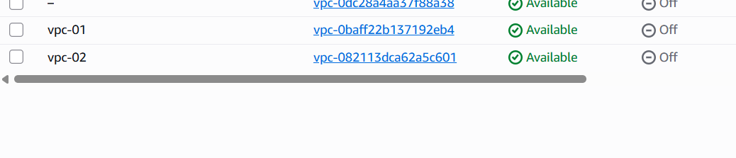
* Create public and private subnets for each of them ,

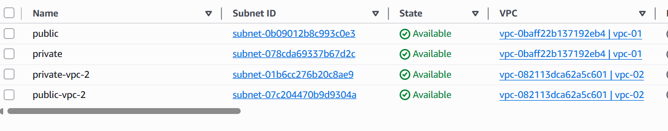

* Now create transit gatway
* 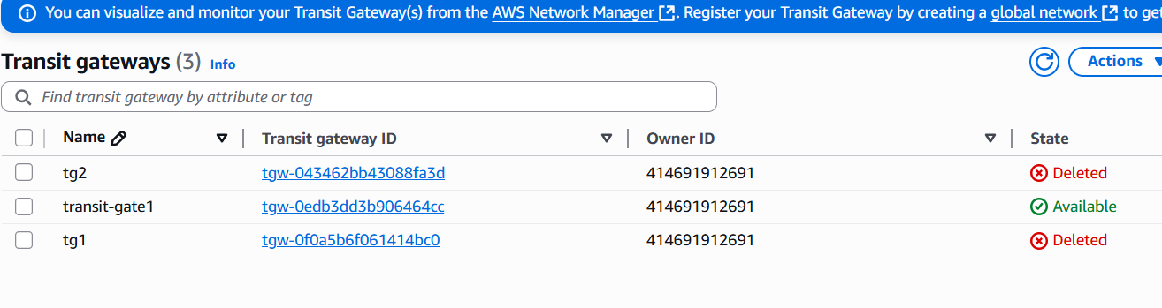
* Enable
* 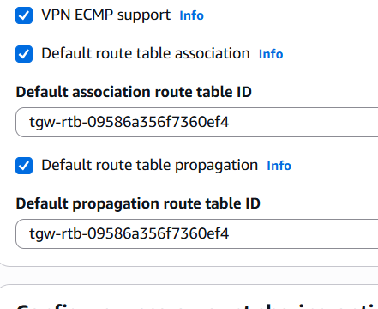
* Create transit attachment
* Add vpc 1 to it and one subnet
* Create 2 transit attachment
* Add vpc 2 to attachment

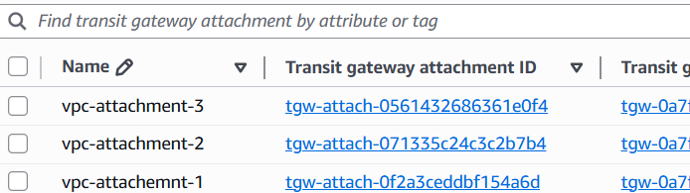

* 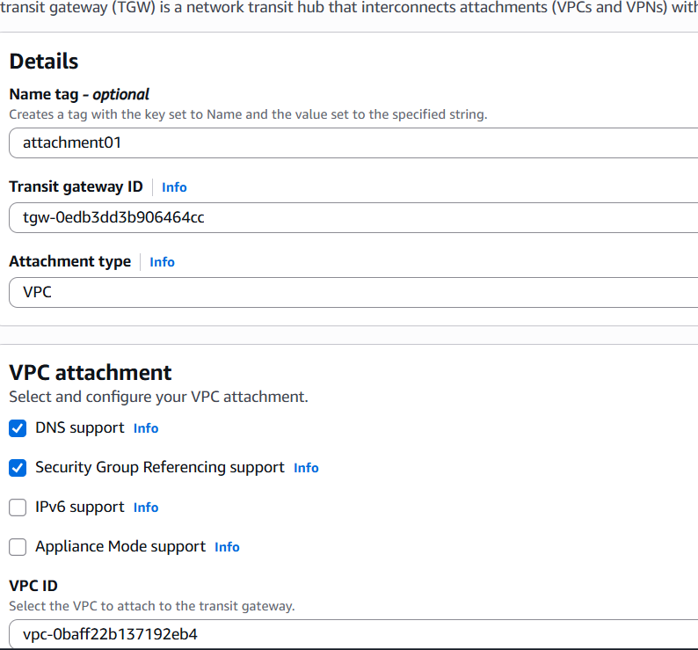
* Create second attachment for vpc2
* 
* Now edit route in route taqble s by adding transit gateway
* 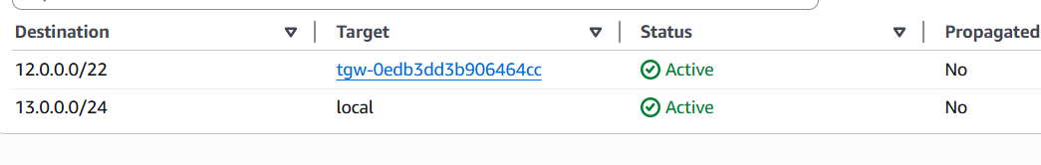
* Now launch an instance with vpc 1 and , 1 subnet
* Give inbound rules to every instance security group as , all traffic with the particular ip
* 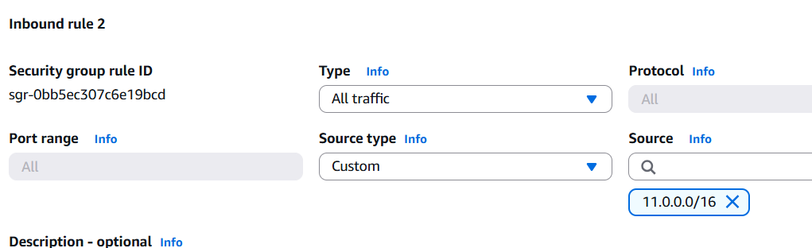
* Now open and connect to terminal by ssh
* And check
* Use the 2nd instance public ip and ping public ip
* 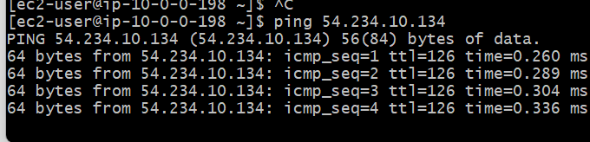



* go aws console
* navigate to vpc
* select peering connections
* vpc id requester
* 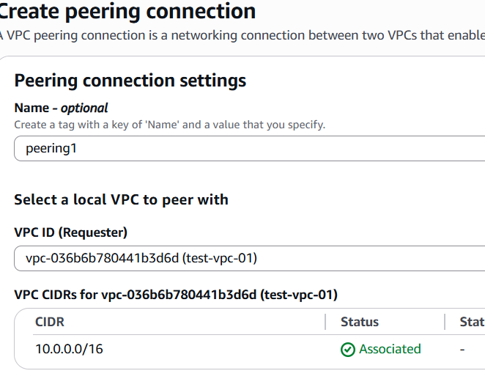
* 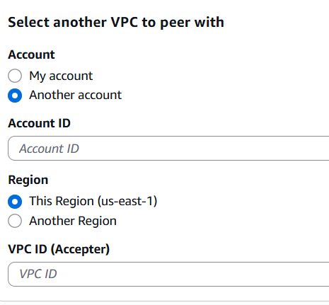
* Select another account
* If it isfrom other region select another
* 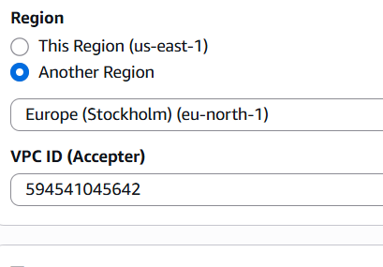
* Create a connection
* 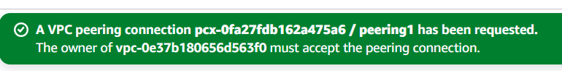
* Peering connection successful
* 

1. . Set up a VPC Endpoint.

* Create a vpc
* 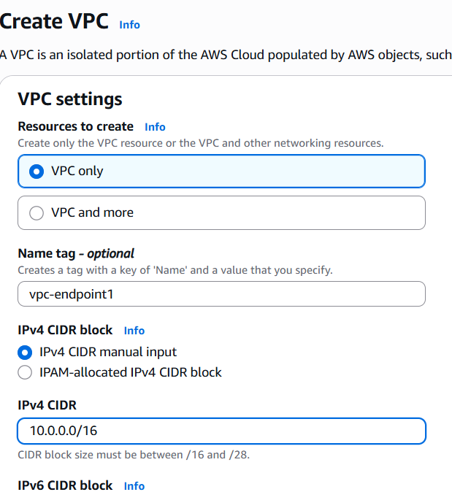
* Create one public subnetand one private subnet
* 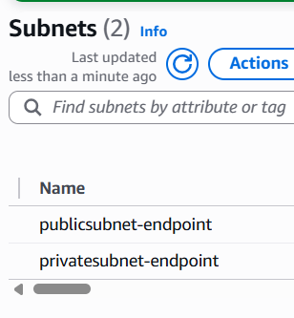

Now create a interne tgate and attach to vpc ,and public subnets

* Now edit subnet associations in route tables only for public subnets
* 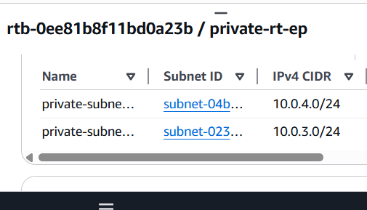
* Launch an instance in with public instance in network settings
* 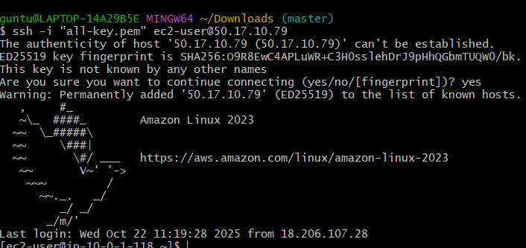
* Now copy the private key of public instance and create a file in private instance and paste the private key
* And give permission chmod 400
* And then enter ssh private instance
* 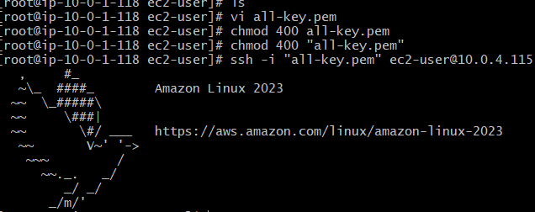
* Now create a user in IAM
* Navigate to iam and enter credintals
* And generate acces key and secret key
* Now , configure aws in cli
* Aws configure
* Enter acces key
* Enter secret key
* Now navigate to vpc and find end point
* Create a endpoint
* Search for s3 and select region
* Select gateway s3 bucket
* Select the vpc
* Select the private routetable for connecrtion
* 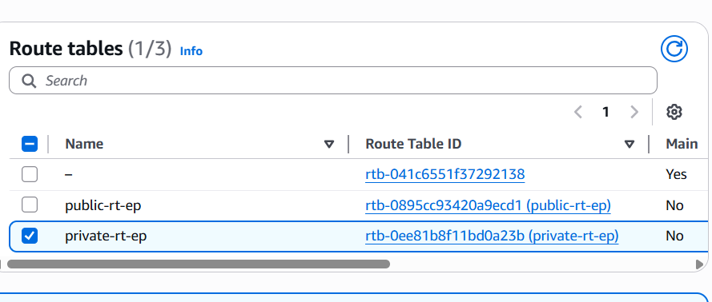
* 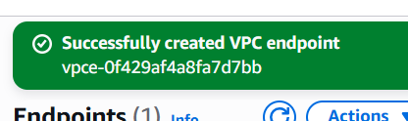
* Navigate to iam and select user
* Open user
* Add permission and
* Select attach policy directly
* 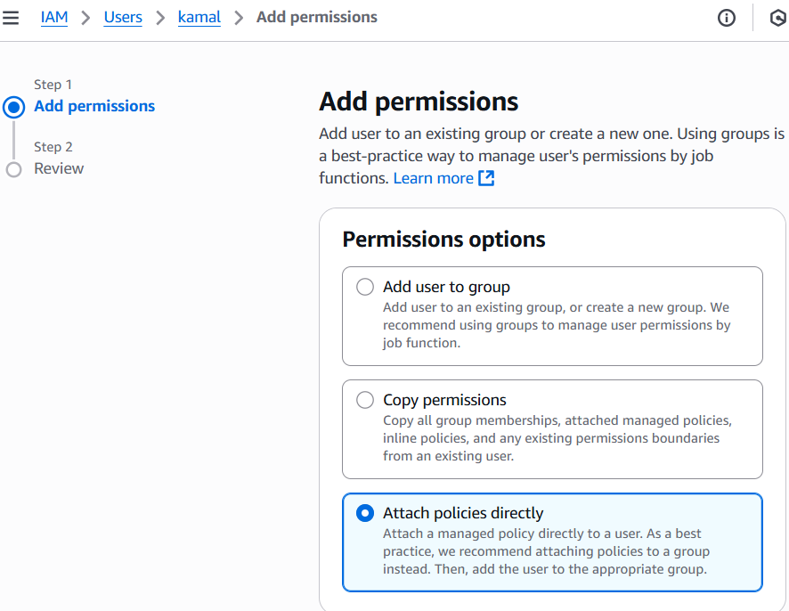
* Search for s3fullacees
* 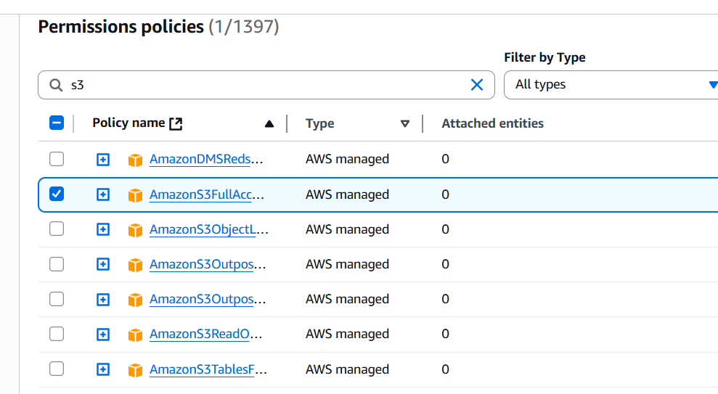
* Permission added
* 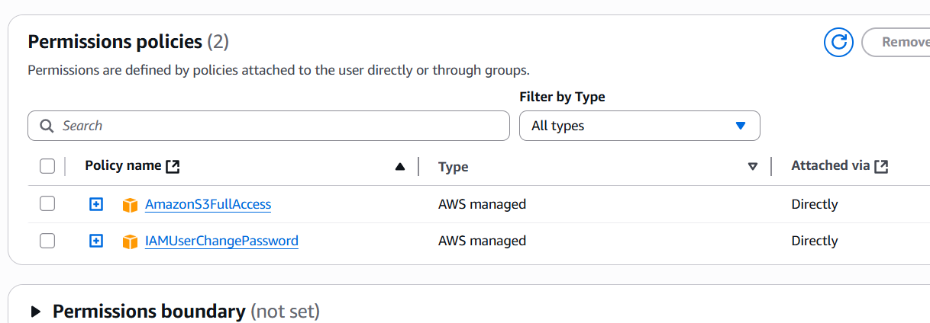
* In cli – enter
* Aws s3 ls
* 
* Now we are communicationg to s3 using endpoint